Introduction:
This project aimed to develop and train a deep learning model capable of accurately recognizing human faces. The system was built upon a pre-trained FaceNet architecture, which was fine-tuned to perform face classification on a custom dataset. The primary goal was to assess how well the model learns facial representations and how effectively it generalizes to unseen images.
The evaluation process focused on key performance metrics including accuracy, precision, recall, F1-score, and false acceptance rate (FAR). These metrics provided a clear measure of how the model balanced between correctly identifying known individuals and avoiding false recognitions.
FaceNet was selected for this task due to its proven ability to generate compact and discriminative face embeddings. Unlike conventional convolutional neural networks that focus solely on feature extraction, FaceNet learns to map each face into a multidimensional embedding space where Euclidean distance directly represents visual similarity. This approach enables more reliable recognition and verification by measuring how close or far apart two embeddings are within that space.
Alternative architectures such as ResNet-50, and InceptionV3 were also considered during model selection. While these networks perform well in general image classification, they are less optimized for facial identity separation. FaceNet’s embedding-based design offers a more direct and robust approach for comparing faces, leading to improved recognition accuracy, scalability, and efficiency in real-world applications.
.
Model Setup
The model was based on the InceptionResnetV1 architecture from the FaceNet framework, pre-trained on the VGGFace2 dataset.
This setup leveraged transfer learning, allowing the network to benefit from pre-learned facial feature representations obtained from a large and diverse face dataset.
To adapt the model for the specific face recognition task, the classification head was enabled and reconfigured to output the same number of classes as the custom dataset.
This modification allowed the model to perform multi-class identity classification instead of generic embedding extraction.
All layers of the network were kept trainable, enabling full fine-tuning of the pre-trained parameters on the new dataset.
This approach ensured that the model could refine both low-level and high-level features to match the characteristics of the new images while maintaining the generalization power learned from VGGFace2.
The Cross-Entropy Loss function was used to optimize the classification objective, and the Adam optimizer with a learning rate of 0.0001 was employed to balance convergence speed and stability.
The training was conducted for 6 epochs using mini-batches of 16 images, with both training and validation accuracy tracked at each epoch.

Training Process
The training process began with the preparation of the dataset, which was divided into training and validation sets. All images were resized to 160×160 pixels and normalized to maintain consistent input quality. The model was trained for six epochs with a mini-batch size of sixteen, allowing for balanced memory usage and stable gradient updates.
During each epoch, the training phase started with images being passed through the FaceNet model to generate predictions. These predictions were compared against the true class labels using the Cross-Entropy Loss function, which quantified the difference between predicted and actual outcomes. The Adam optimizer was employed to update the model’s parameters efficiently based on the computed gradients, supporting rapid and stable convergence. After processing each batch, gradients were cleared, and the weights were updated iteratively to improve accuracy.
At the end of each epoch, training loss and accuracy were computed to monitor progress. The model then entered the validation phase, where it was evaluated on unseen data. In this stage, performance metrics such as accuracy, precision, recall, and F1-score were calculated to measure the model’s generalization capability. If the model achieved a higher validation accuracy than in previous epochs, its parameters were saved as a checkpoint to preserve the best-performing version.
Across the six training epochs, the model demonstrated continuous improvement in both training and validation performance. This consistent upward trend reflected effective fine-tuning of the pre-trained FaceNet layers and confirmed the model’s strong ability to generalize to new facial identities.

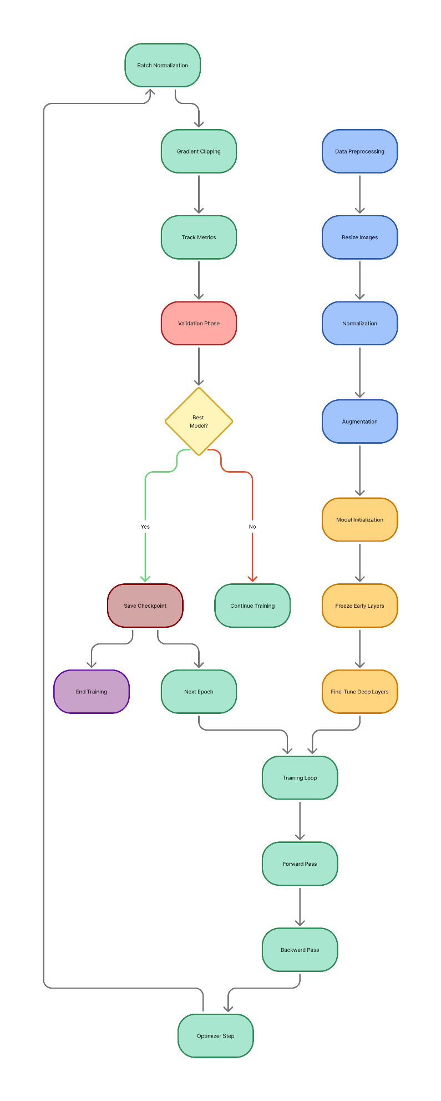
Results
Learning Progress per Epoch
The face recognition model was trained for six epochs, with accuracy measured on both training and validation sets after each epoch. The table below summarizes the observed performance:
Epoch | Training Accuracy (%) | Validation Accuracy (%)
1 | 16.27 | 19.05
2 | 35.01 | 30.86
3 | 52.20 | 43.55
4 | 68.29 | 64.30
5 | 84.53 | 85.44
6 | 96.85 | 95.76

A steady increase in both training and validation accuracy highlights strong learning progression. The gap between these accuracies remained small throughout, indicating that the model did not overfit to the training data and was able to generalize well to unseen samples.​
Final Evaluation Metrics
After training, the model with the best validation accuracy was saved and evaluated. The final performance metrics on the validation set were:
- Accuracy: 95.76% (Overall rate of correct classifications)
- Precision: 94.61% (Ratio of true positive identifications out of all predicted positives)
- Recall: 95.76% (Rate of successfully identifying all relevant faces)
- F1-score: 94.75% (Harmonic mean of precision and recall, balancing both metrics)
- False Acceptance Rate (FAR): 0.00% (No incorrect acceptance of unauthorized identities)
These scores indicate that the model is not only highly accurate, but also balanced between precision and recall, making it both reliable in detecting faces and minimizing missed or false identifications.​
Visualizing the Results
Performance across epochs is further illustrated in the accompanying graphs:
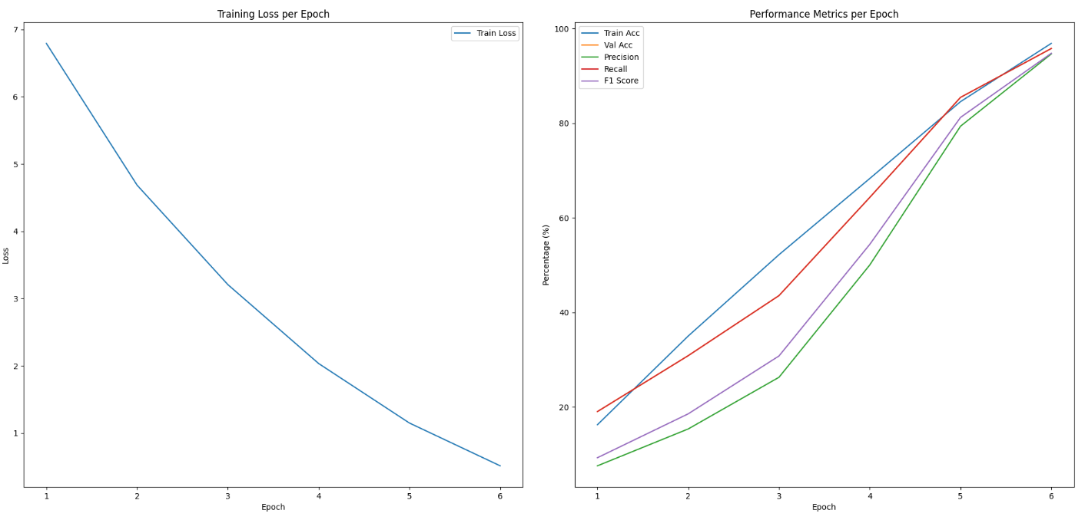

- The training loss curve demonstrates a continuous decline, reflecting effective learning.
- Accuracy, precision, recall, and F1-score curves all steadily rise and converge between 95% and 97% by the end of training, indicating that the model’s learning was stable and no significant overfitting occurred.
Overall the model achieved high, stable, and balanced performance, suitable for real-world facial recognition tasks.

